PSUEDO-CODE

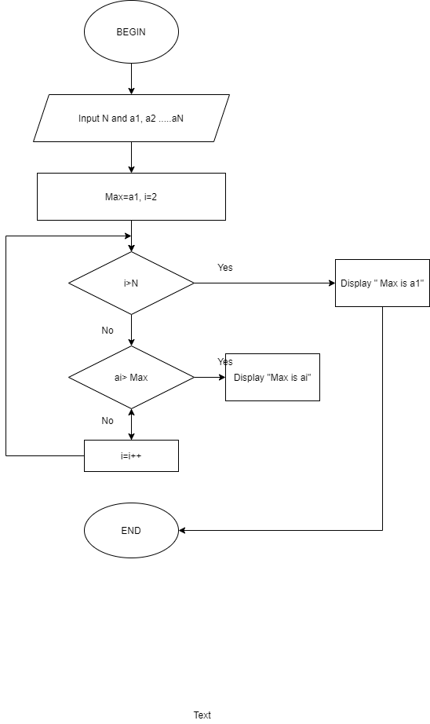

BEGIN

Input N and a1, a2,…aN

Max=a1 , i=2

If i> N

Display “Max is a1”

Else

While ai>Max

Do

Display “Max is ai”

I=i+1

End Do

End if

END